

Assignment-2

Name: Drumil Kotecha Roll Number: C052

Program: BTI-Computer Date of Submission: 14th April 2025

Semester: XII Branch: BTI-Computer-Div-B

Course Name: RPA Total Marks: 20

**------------------------------------------------------------------------------------------------------------------------------**

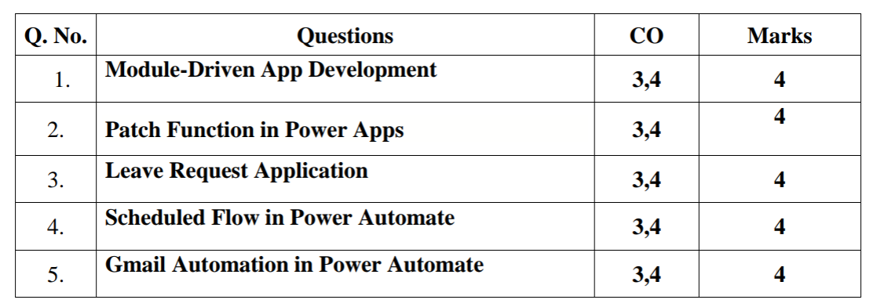

**Answers**

1. Module-Driven App

All:

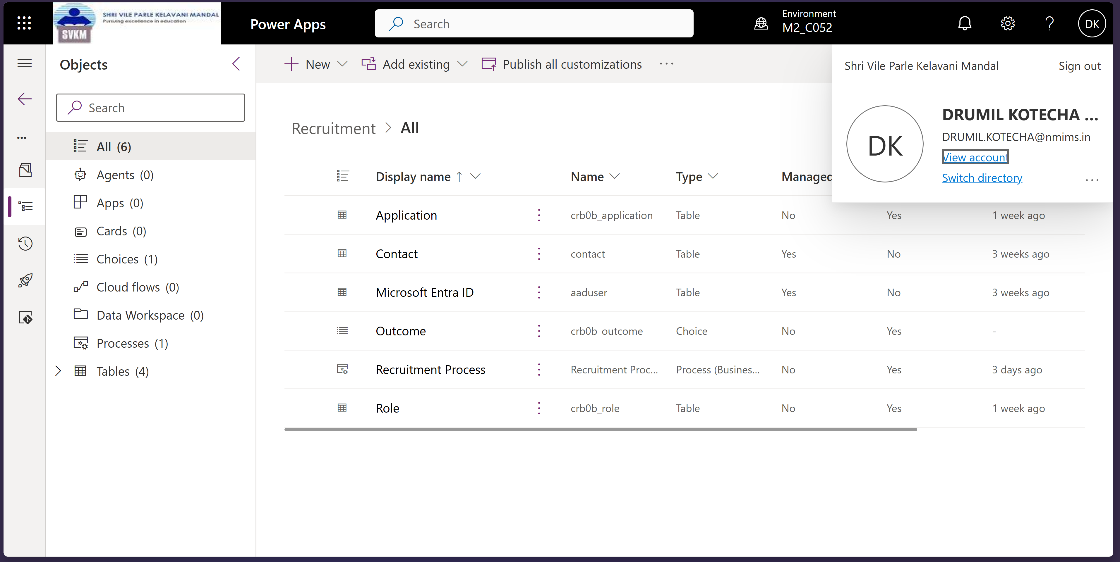

Application columns:

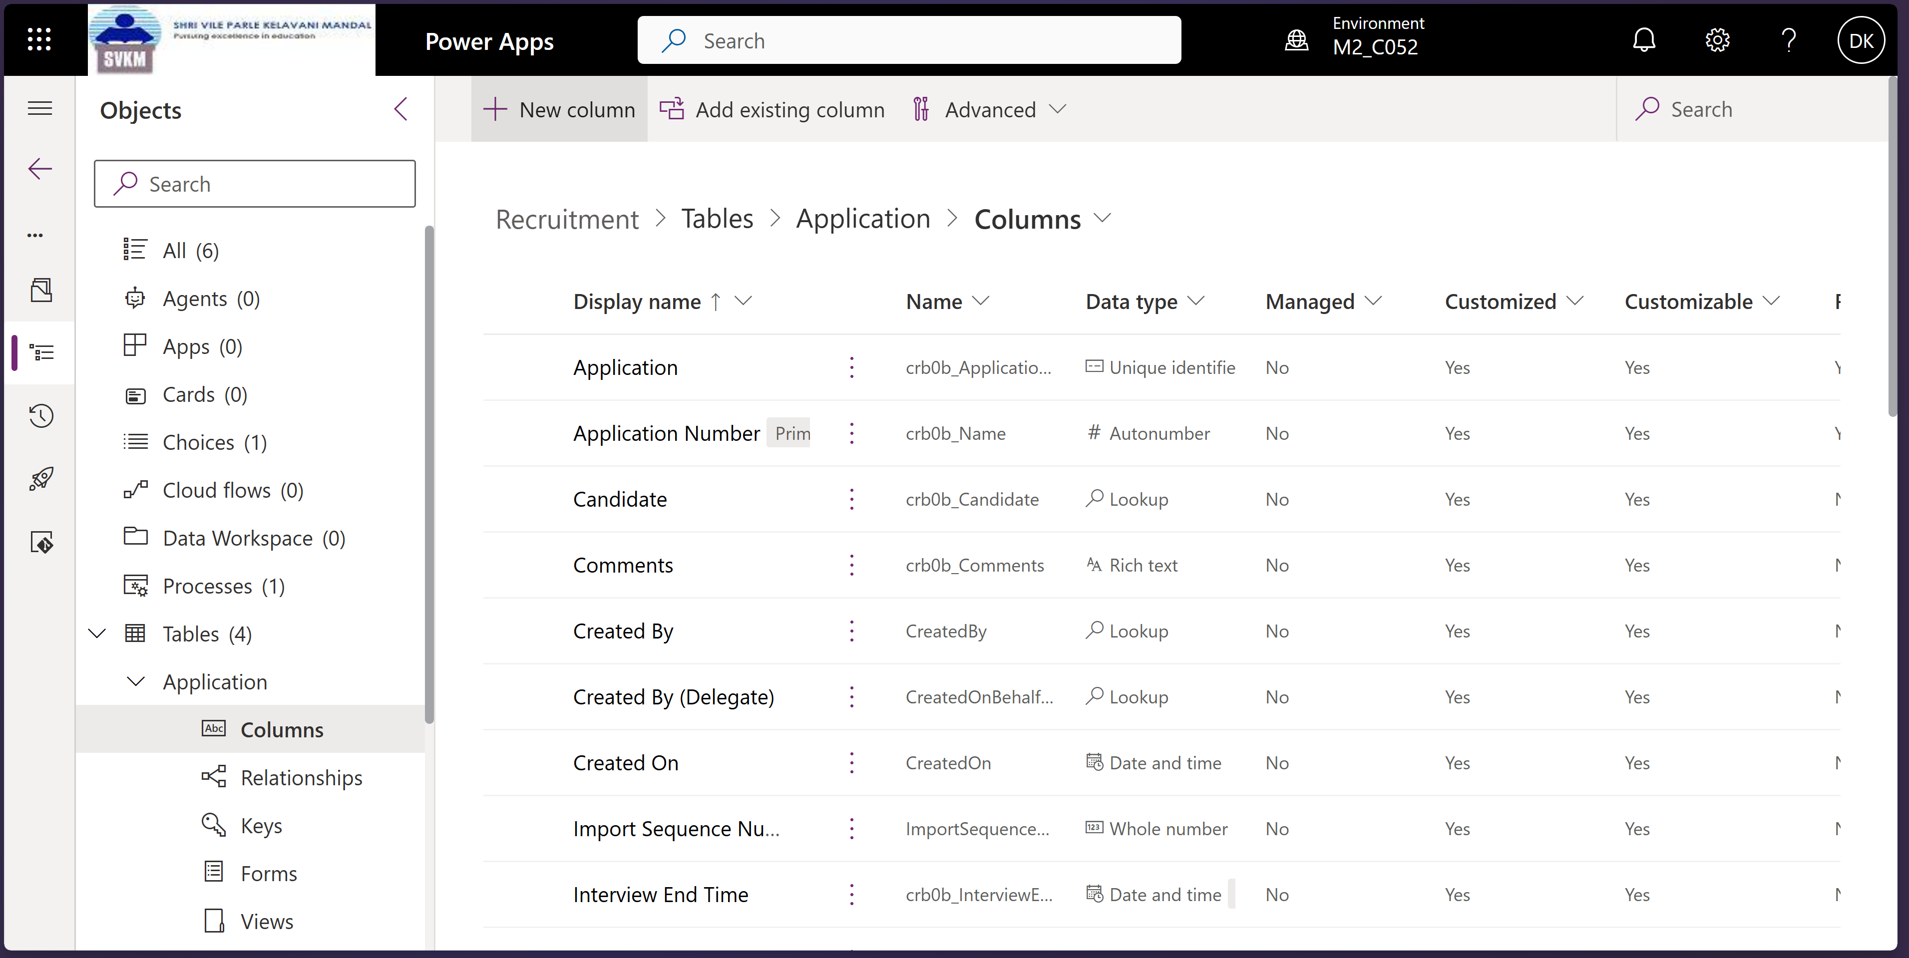

Business Process Flow:

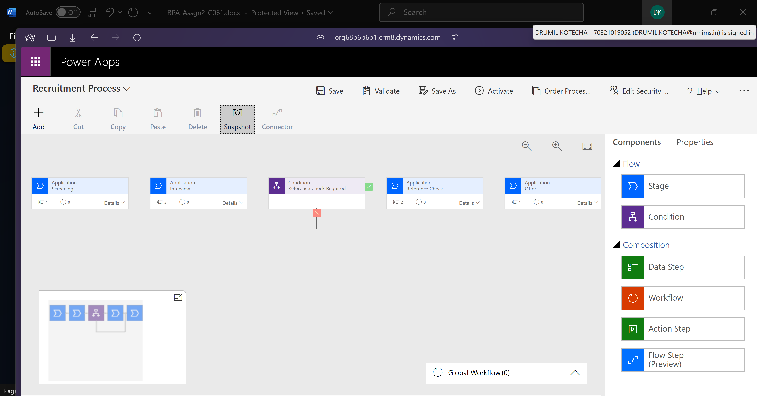

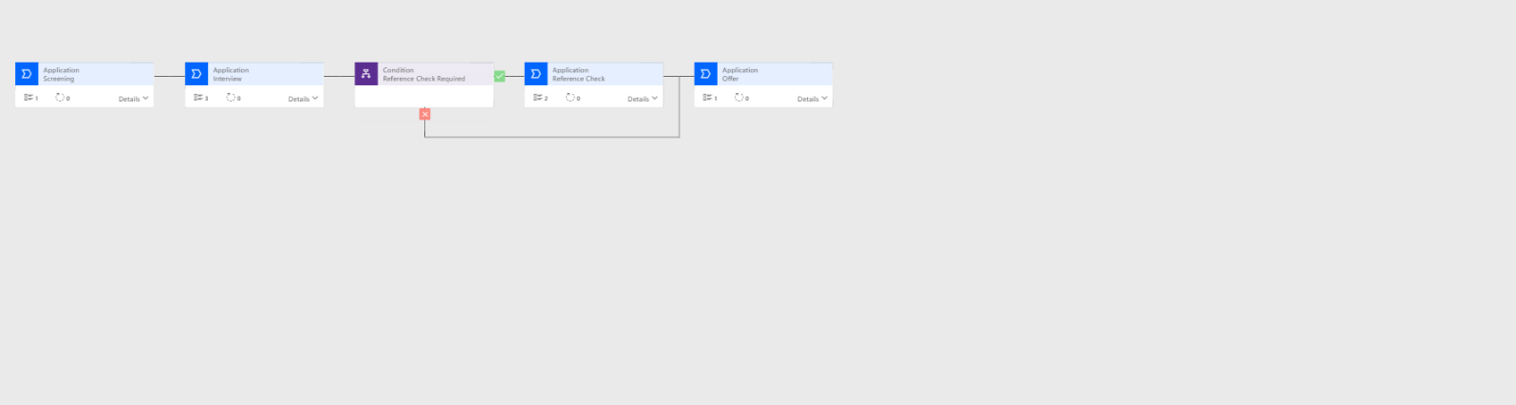

1. Patch Function:

Overall App:

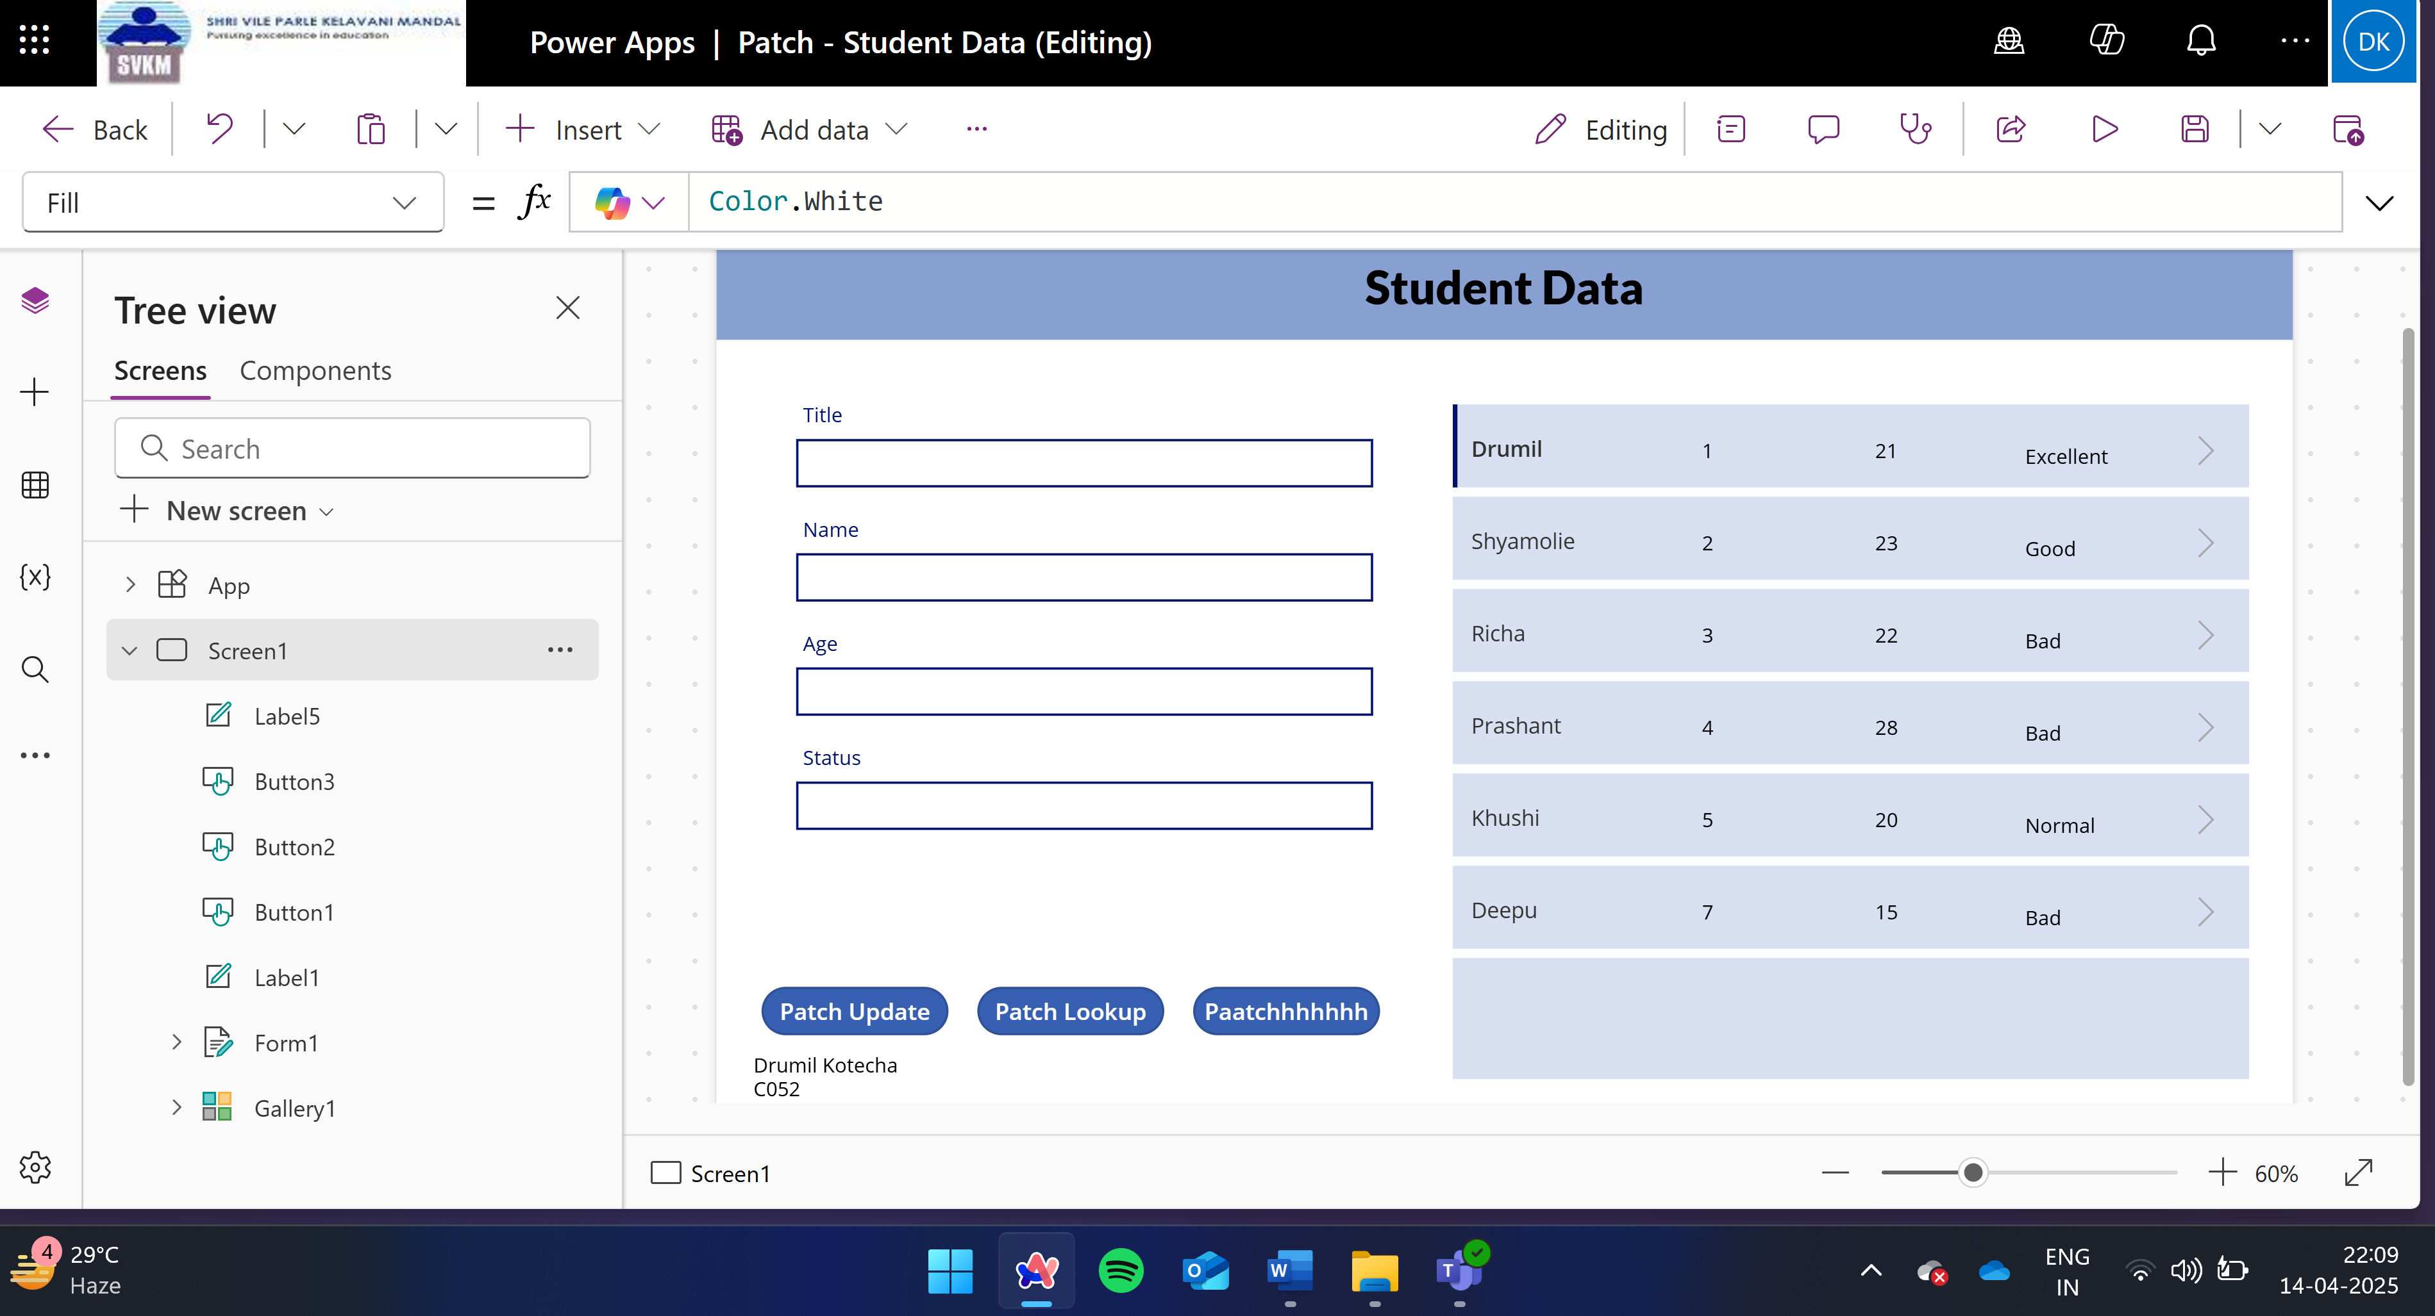

Filling in the form:

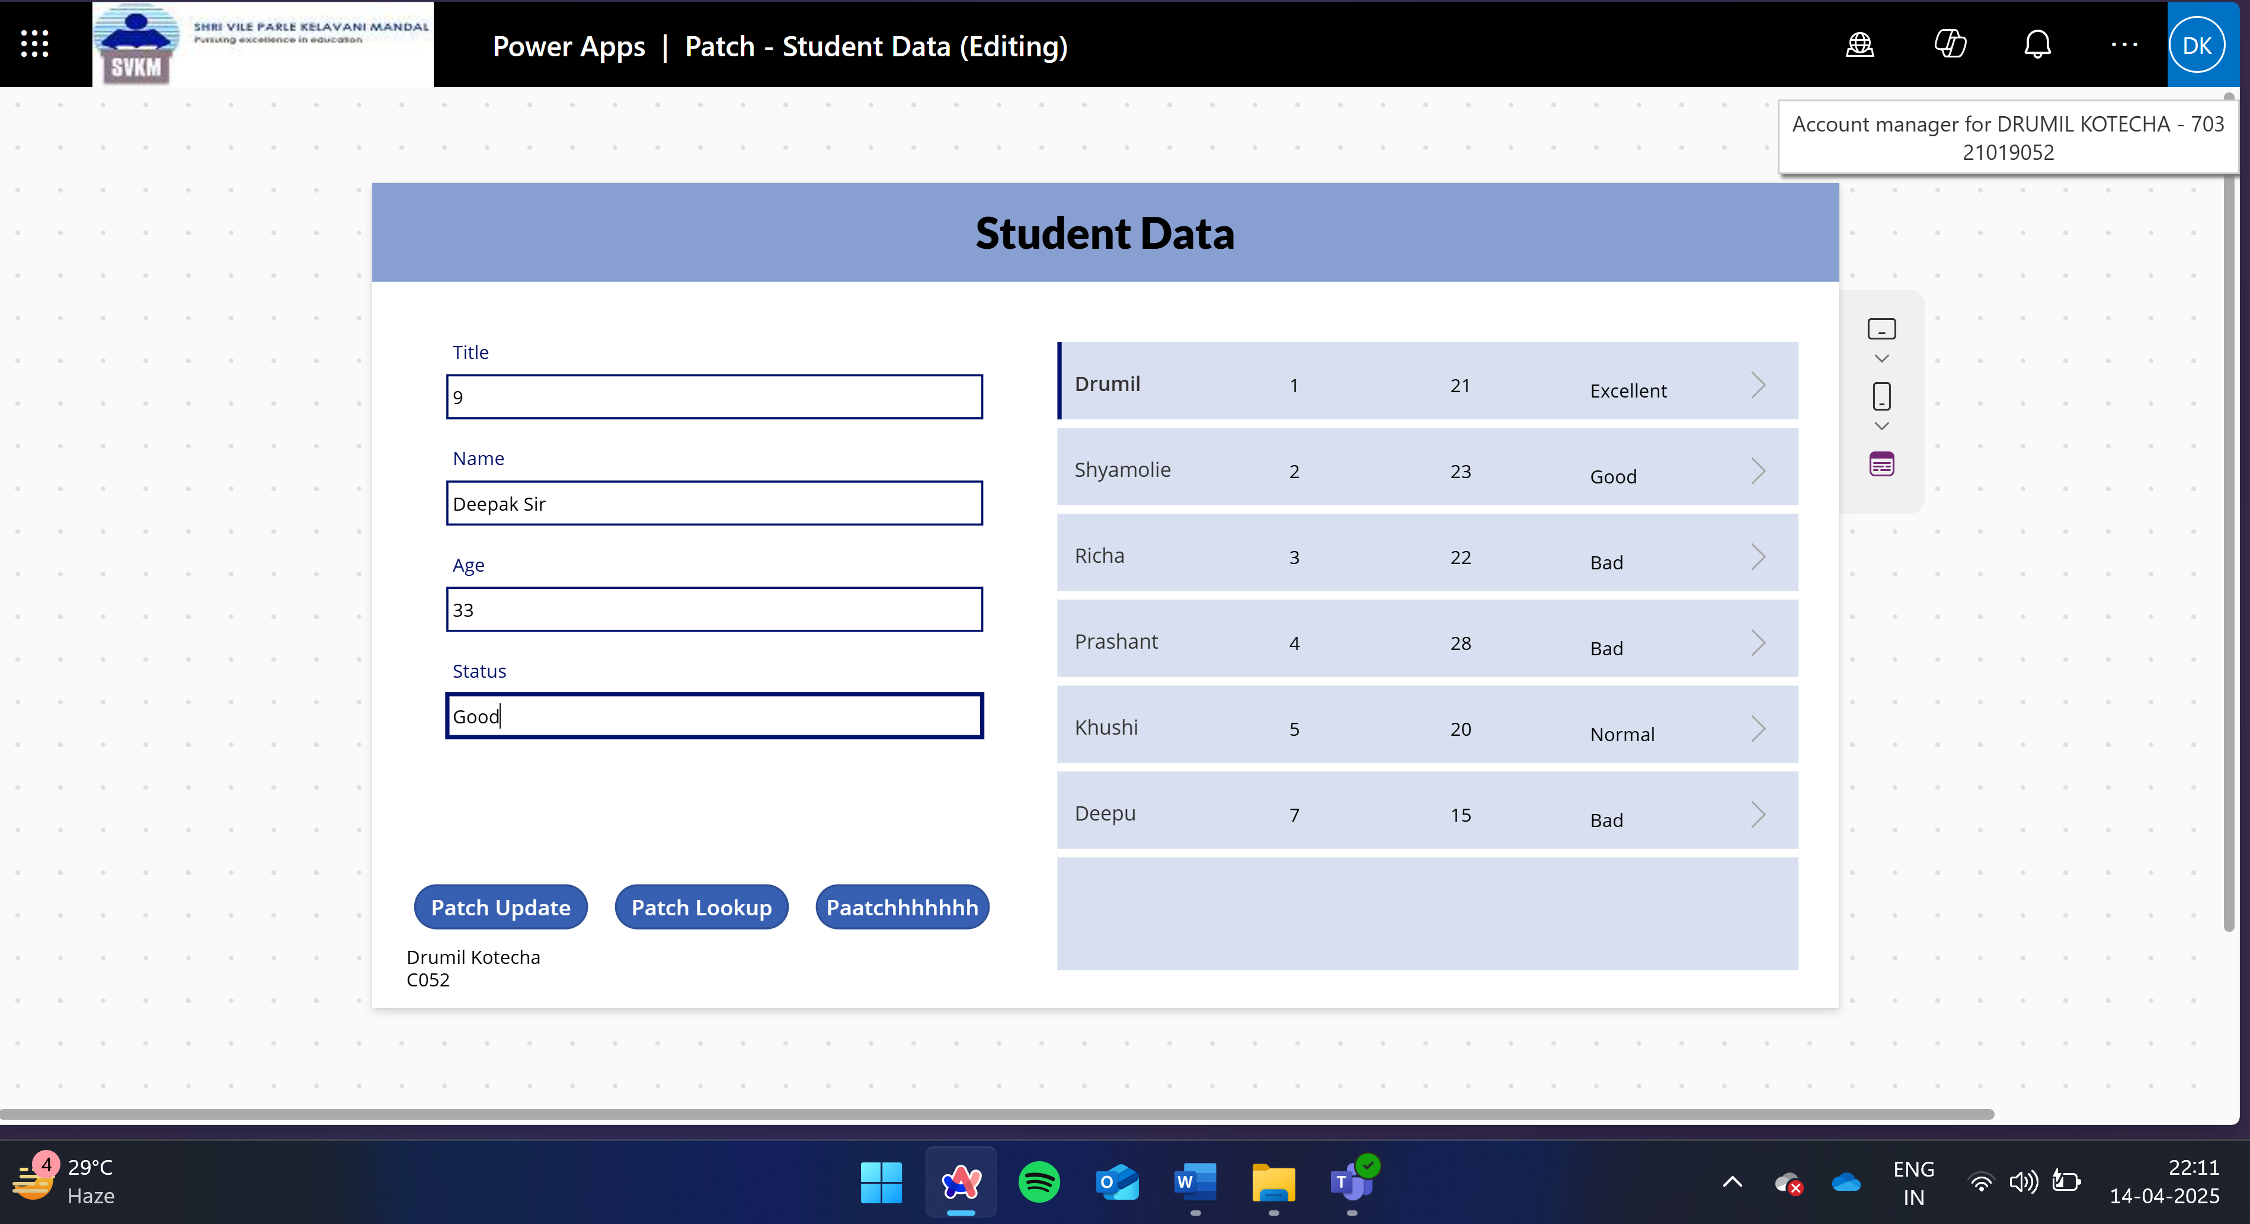

Update:

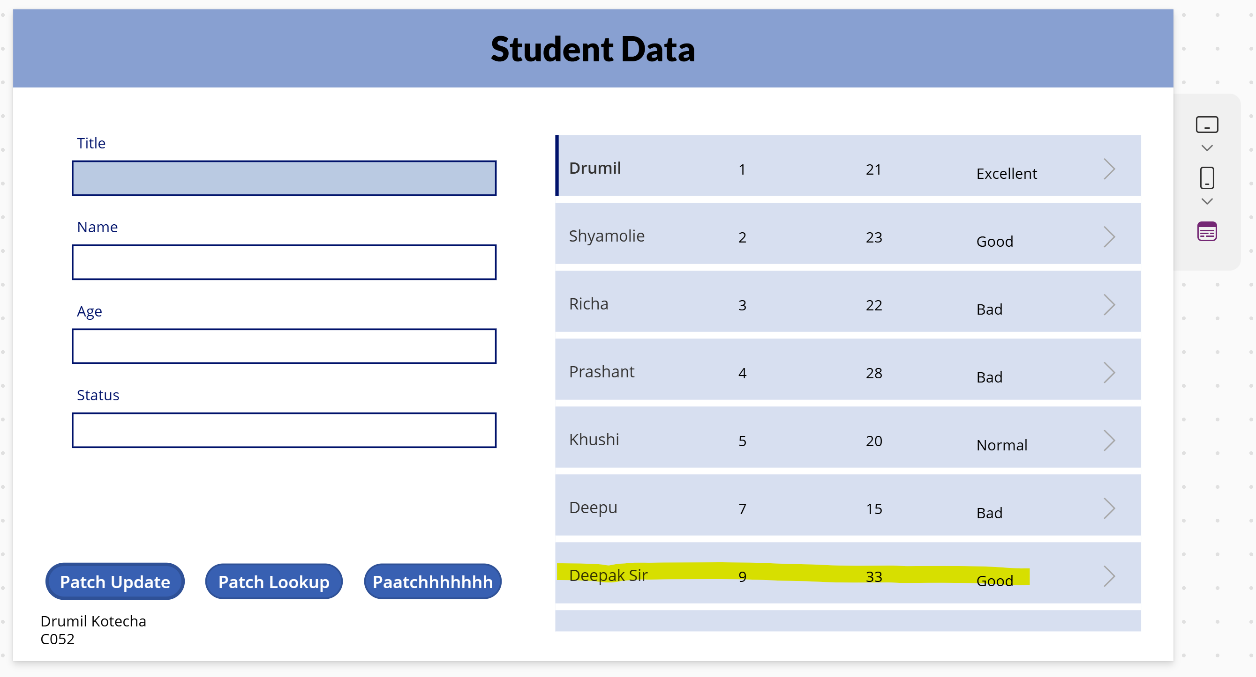

Link: <https://apps.powerapps.com/play/e/default-d1f14348-f1b5-4a09-ac99-7ebf213cbc81/a/863d32c8-4e9f-4558-827d-b9b108a73ceb?tenantId=d1f14348-f1b5-4a09-ac99-7ebf213cbc81&hint=597d62a4-efc0-4da7-ab40-ea70076edabb&sourcetime=1744648680747>

3. **Leave Request Application:**

**Flow Screenshot:**

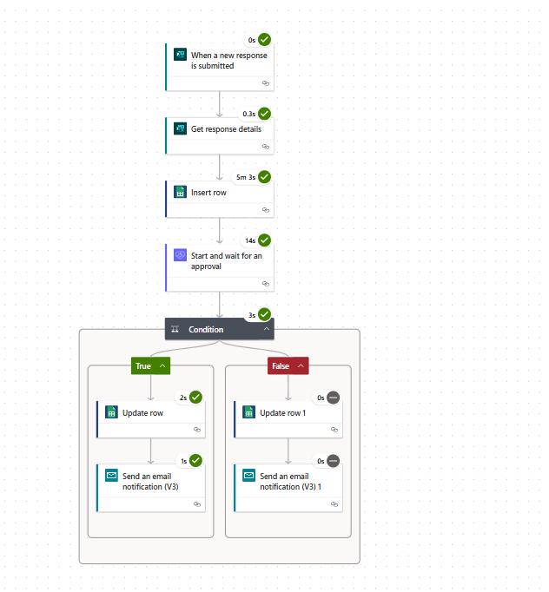

**Empty form:**

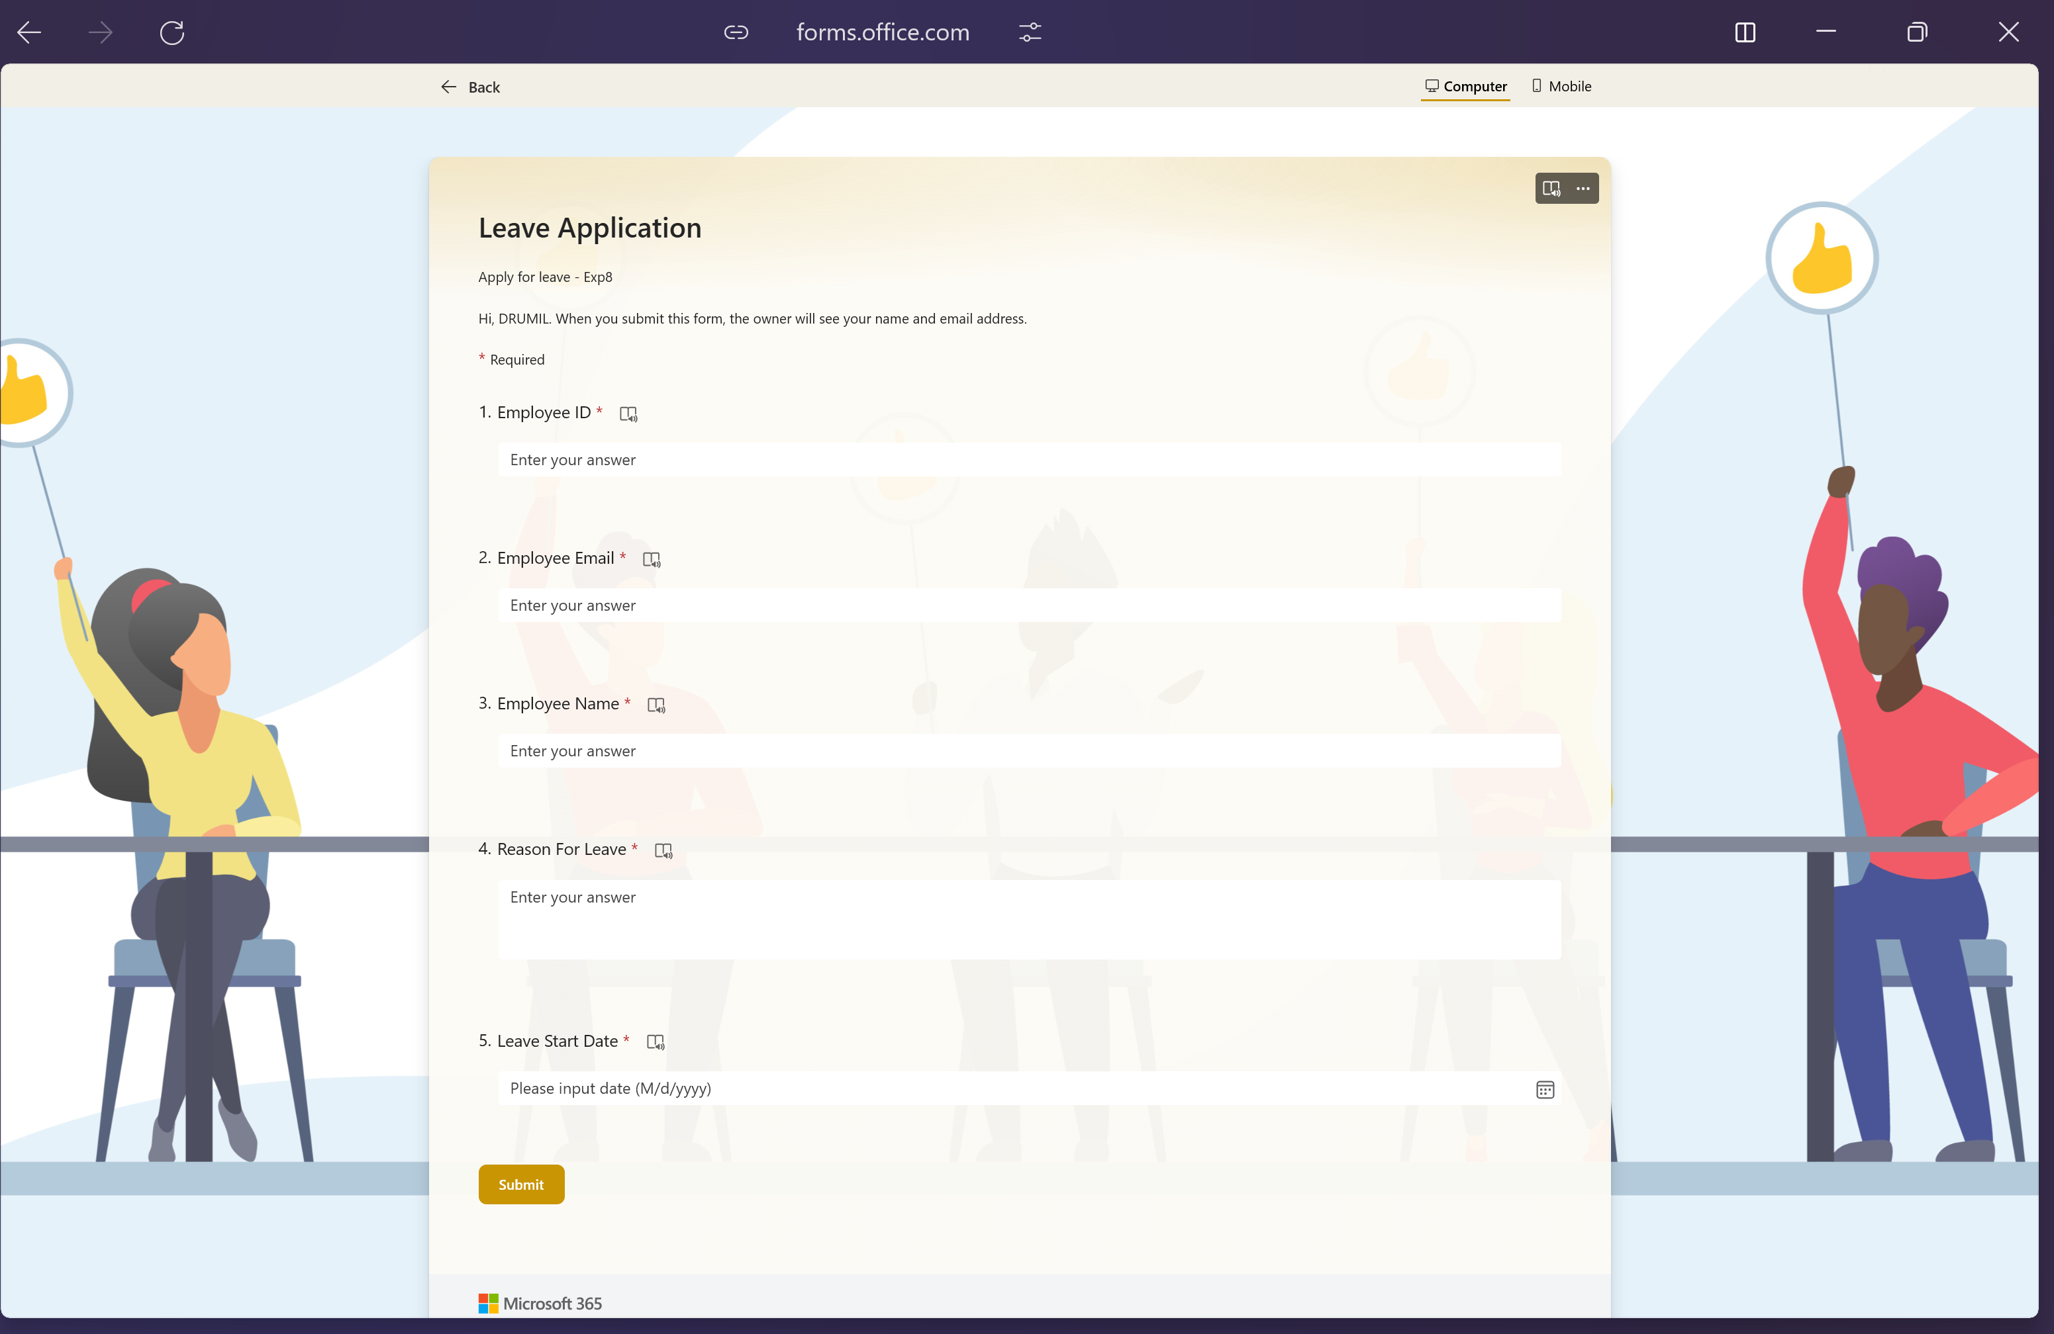

**Flow:**

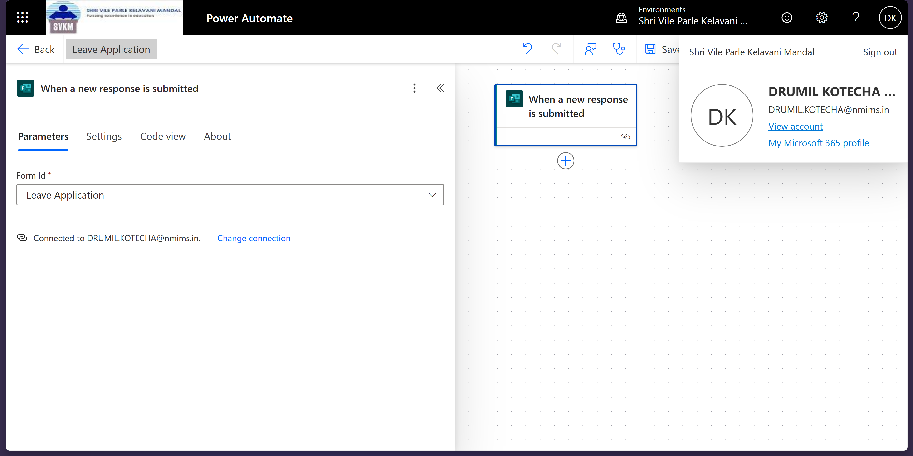

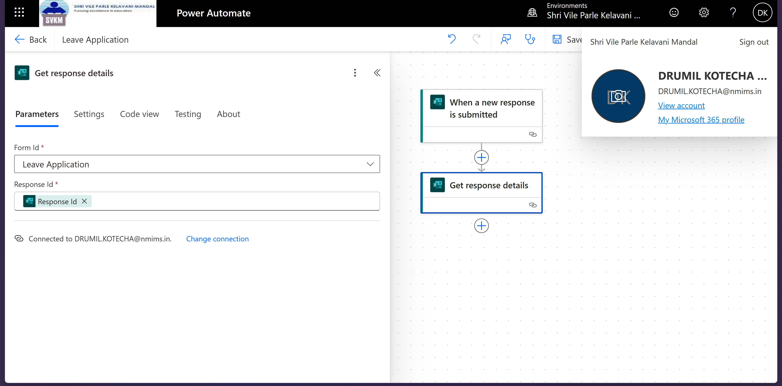

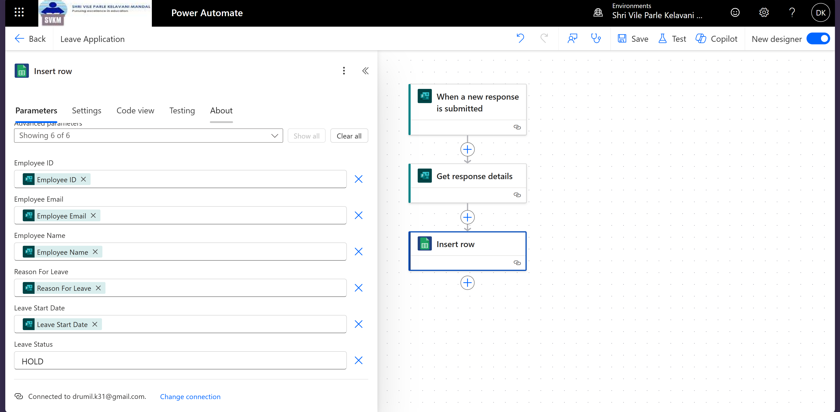

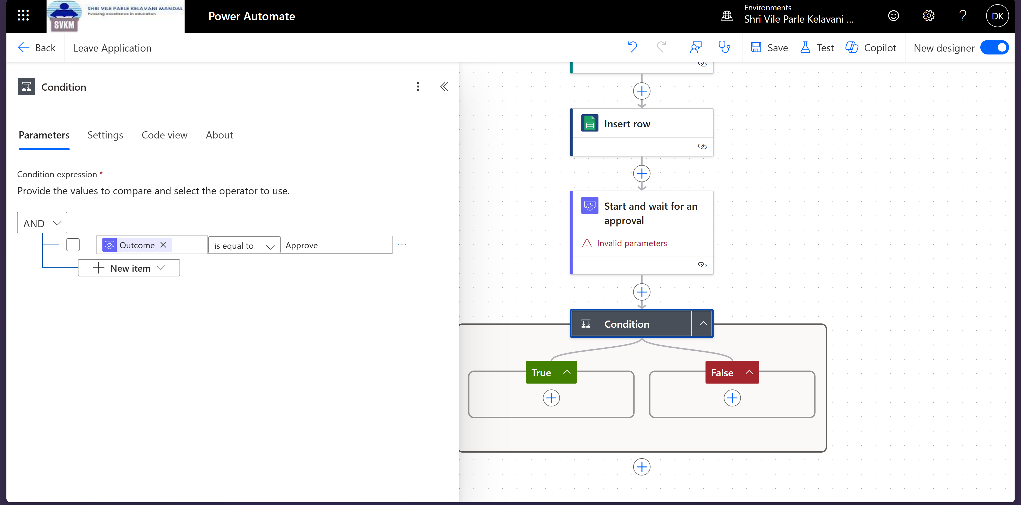

**For Approve:**

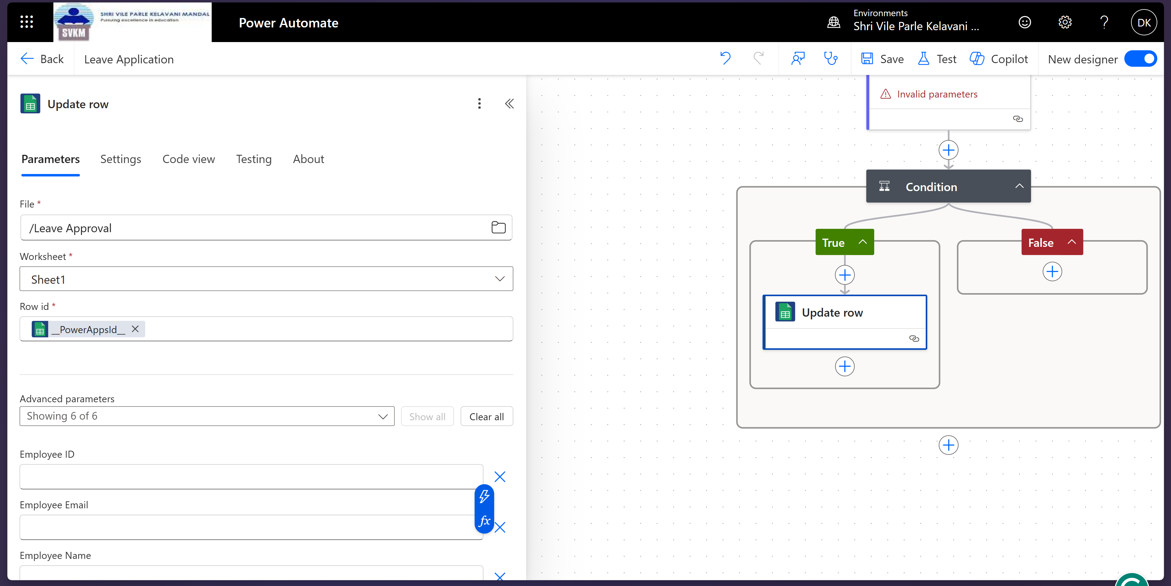

**For deny:**

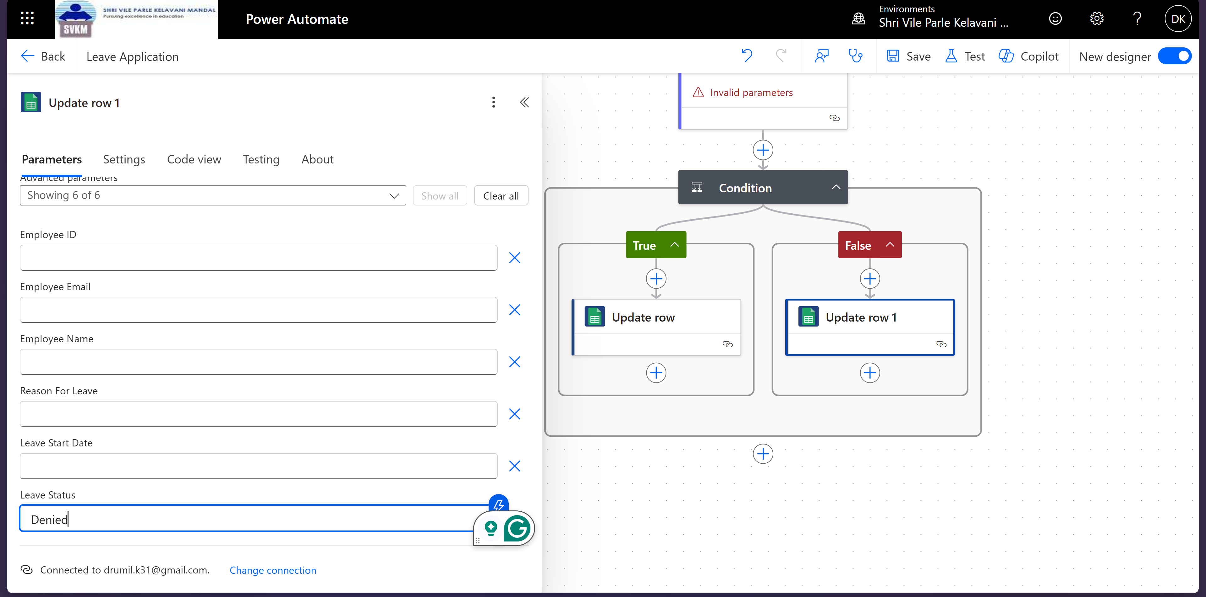

**Approval Notification:**

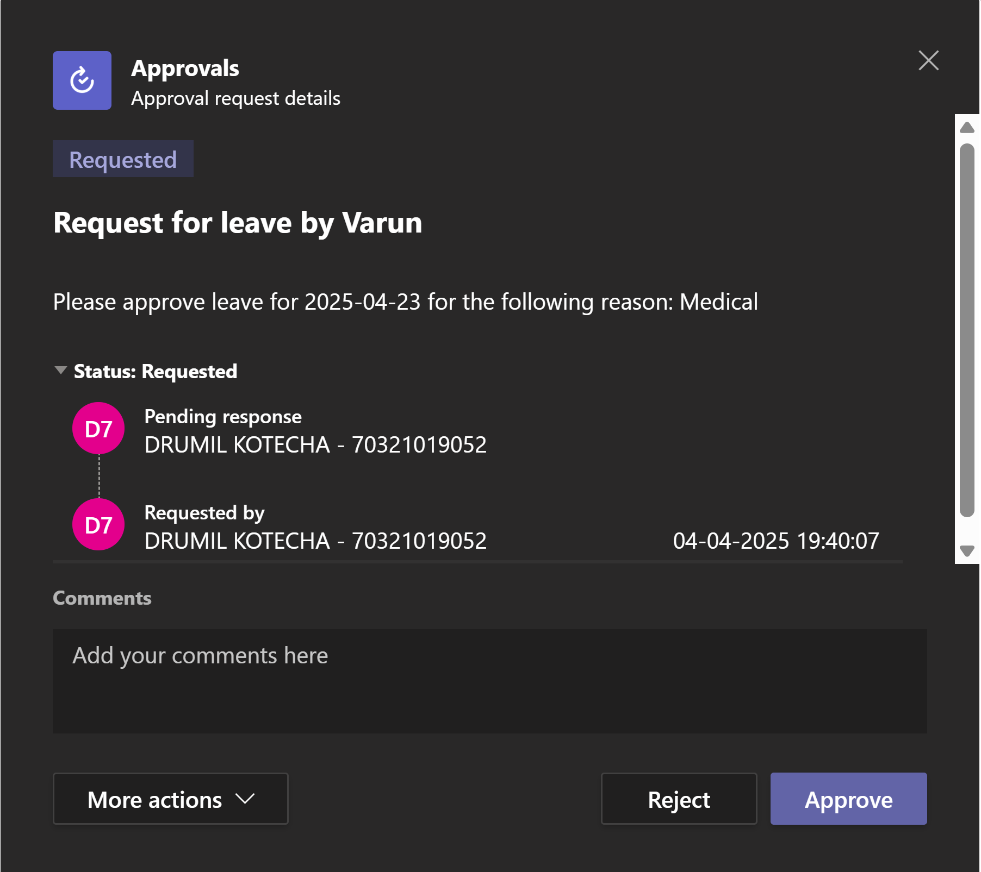

**After Approval, Email sent to Applicant:**

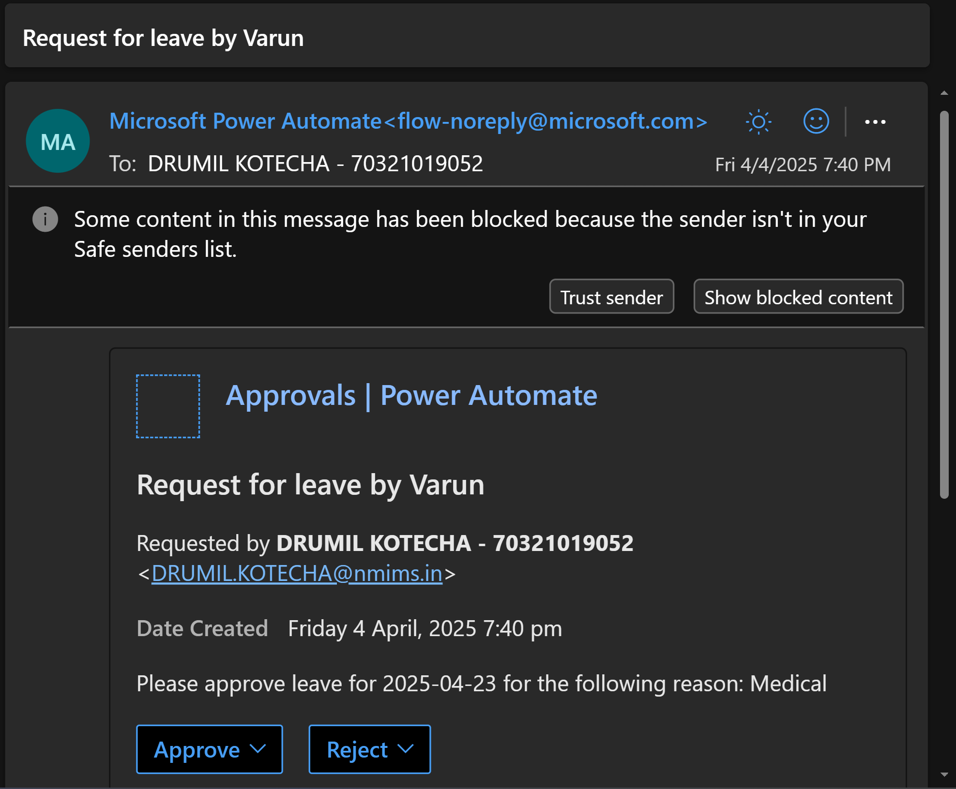

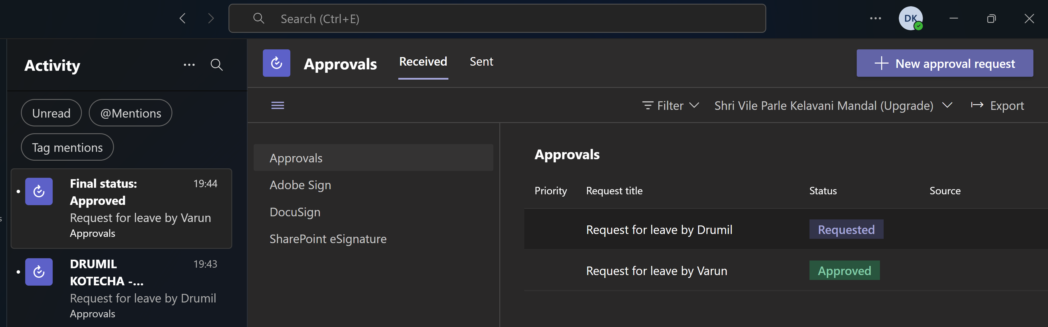

**Leave application flow**

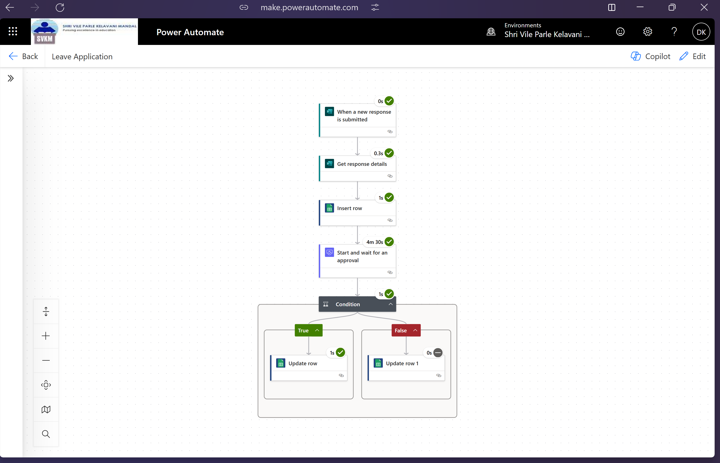

**Google sheet before response submitted:**

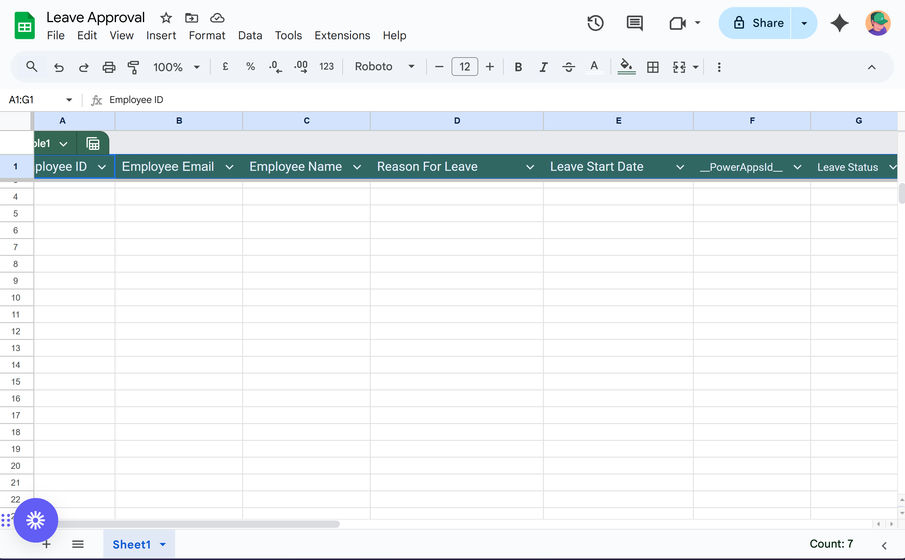

**Google sheet after response submitted:**

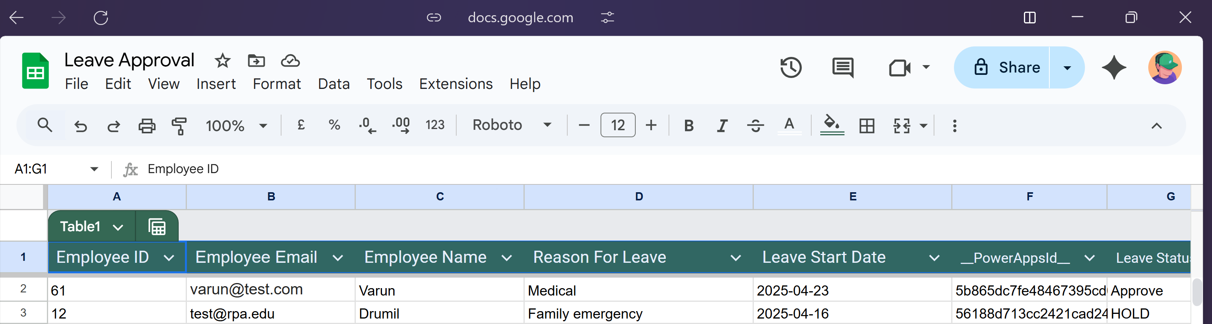

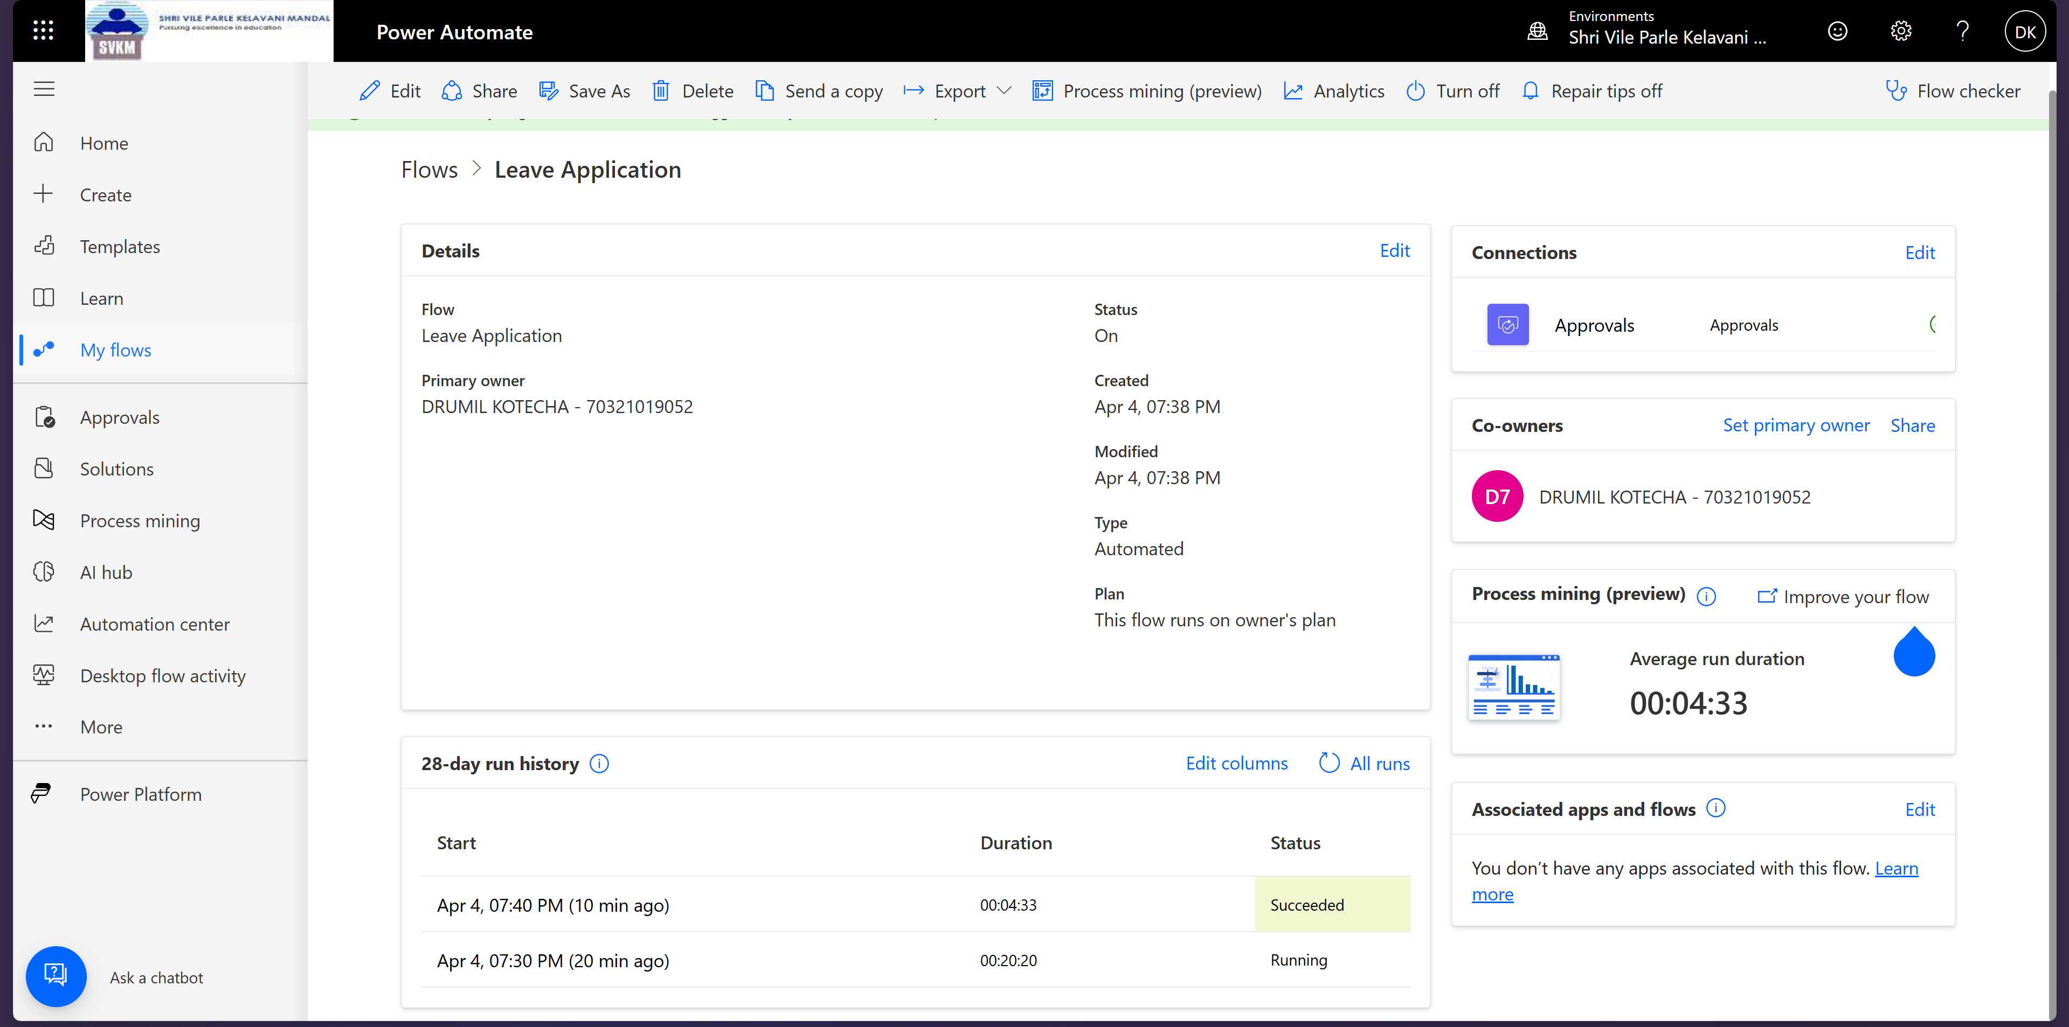

**4. Scheduled Flow in Power Automate**

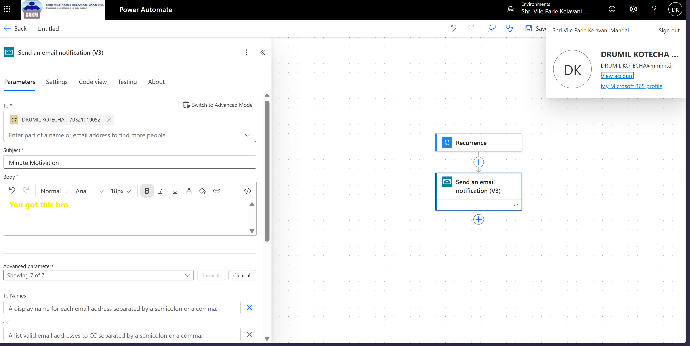

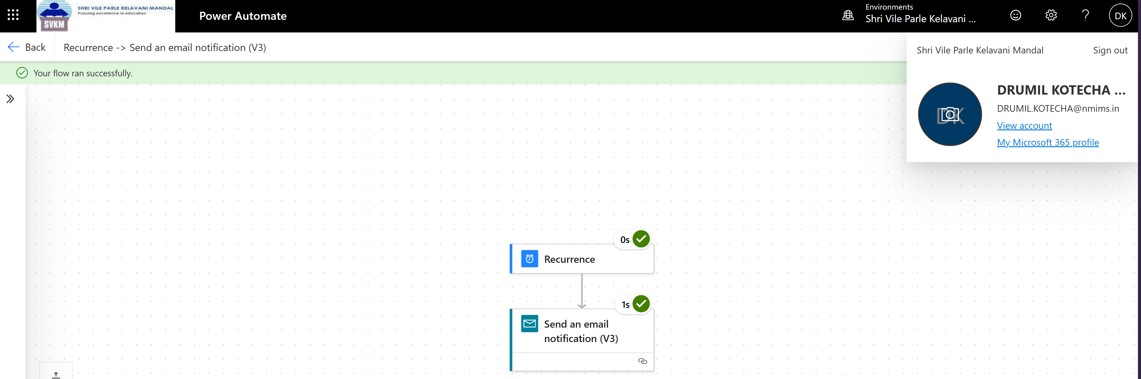

Email:

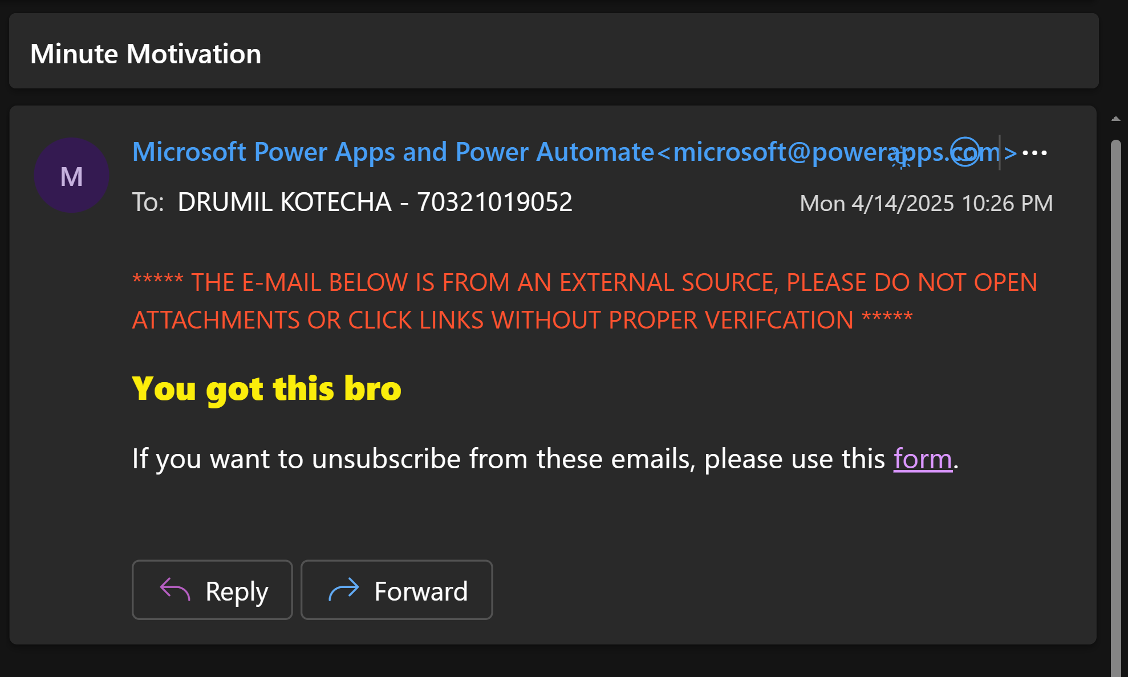

5. **Gmail Automation in Power Automate**

Form:

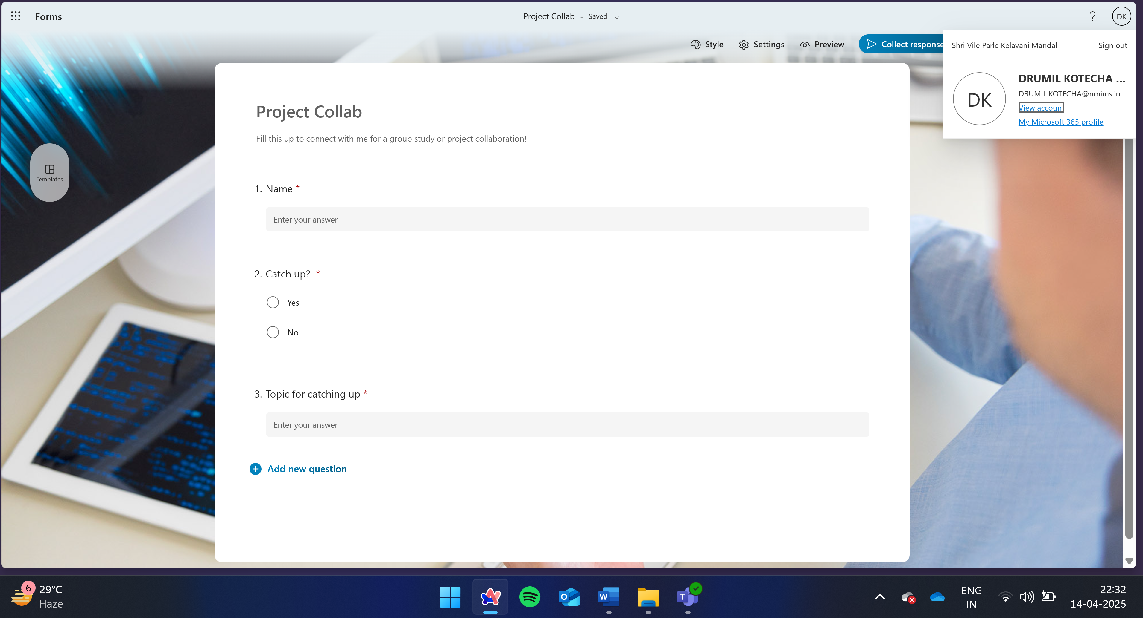

Condition:

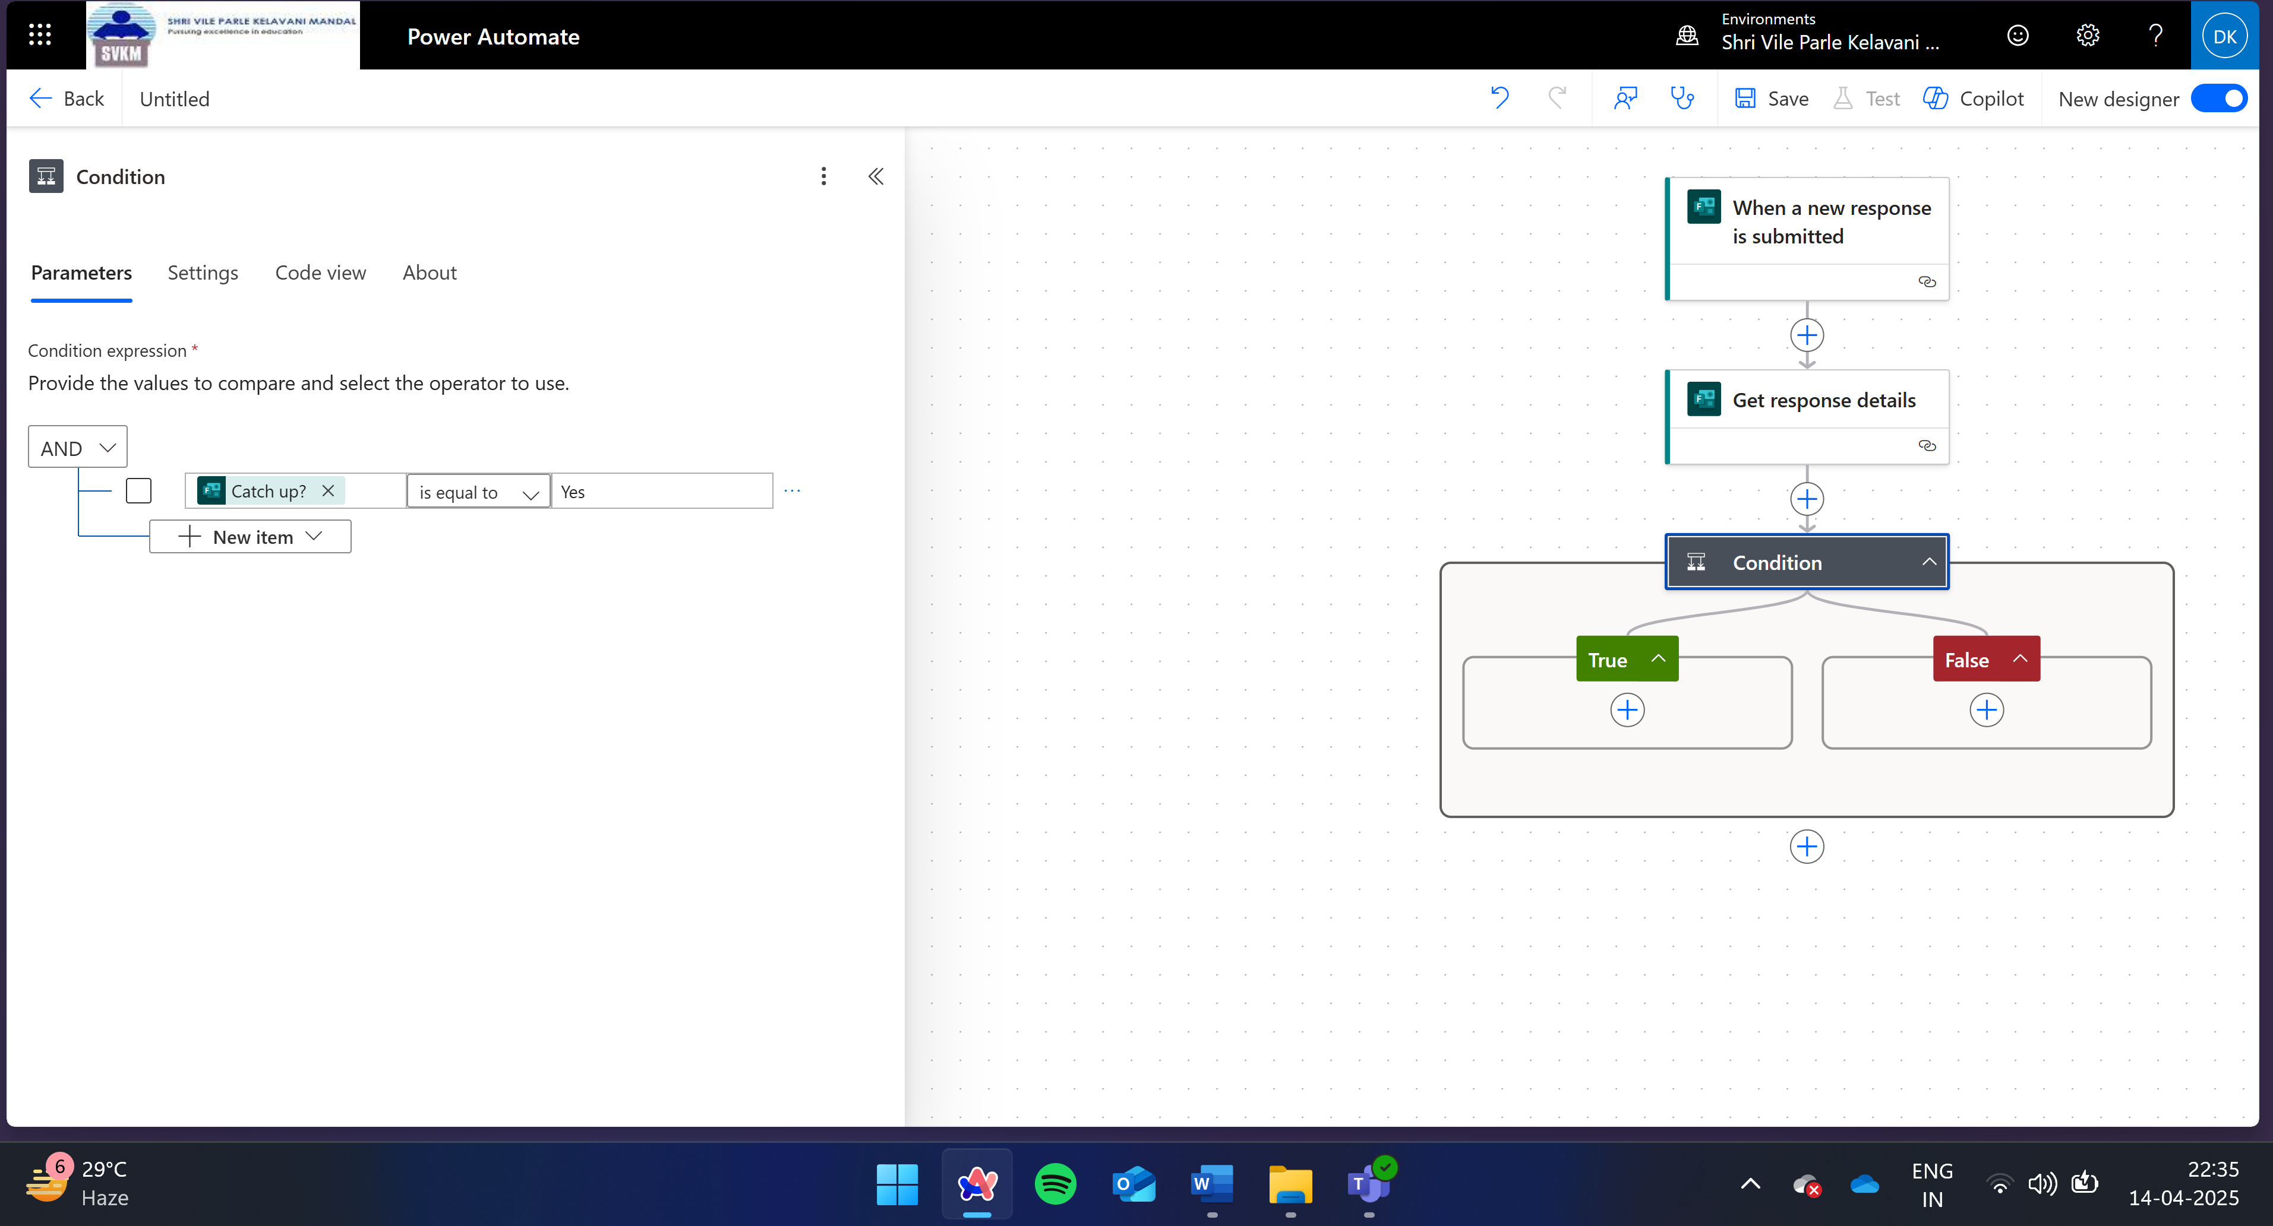

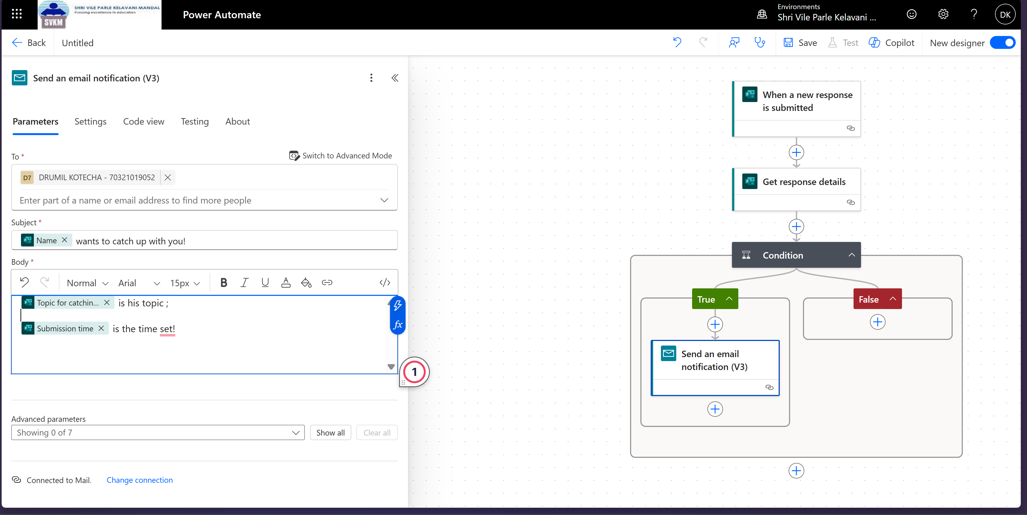

Filled form:

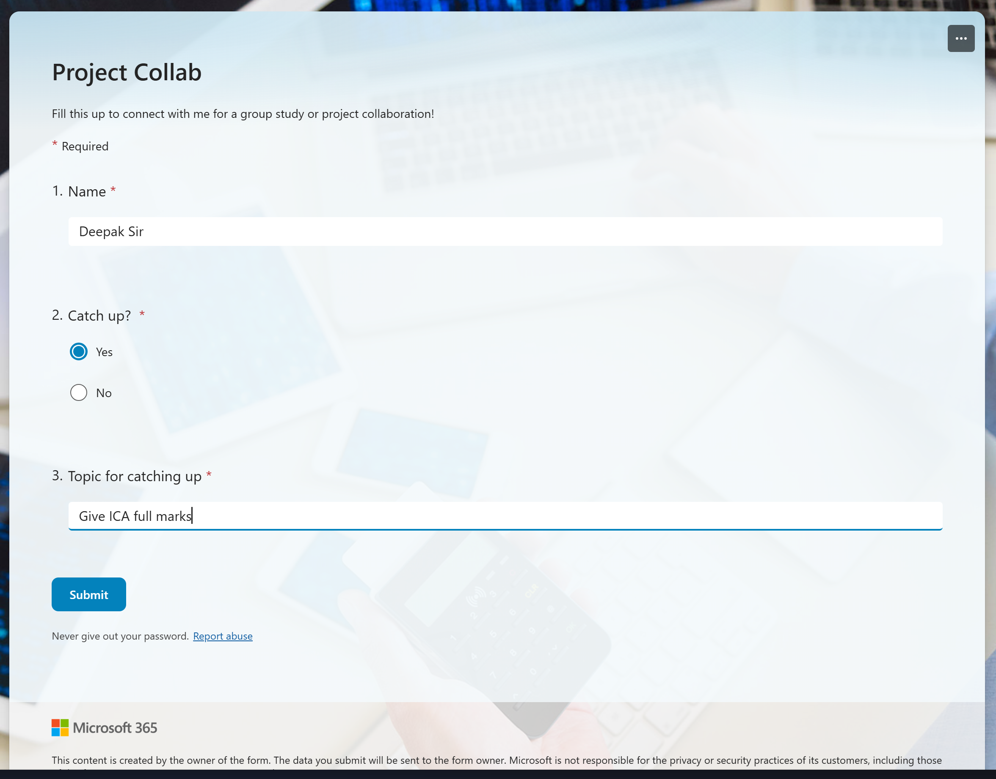

Verify:

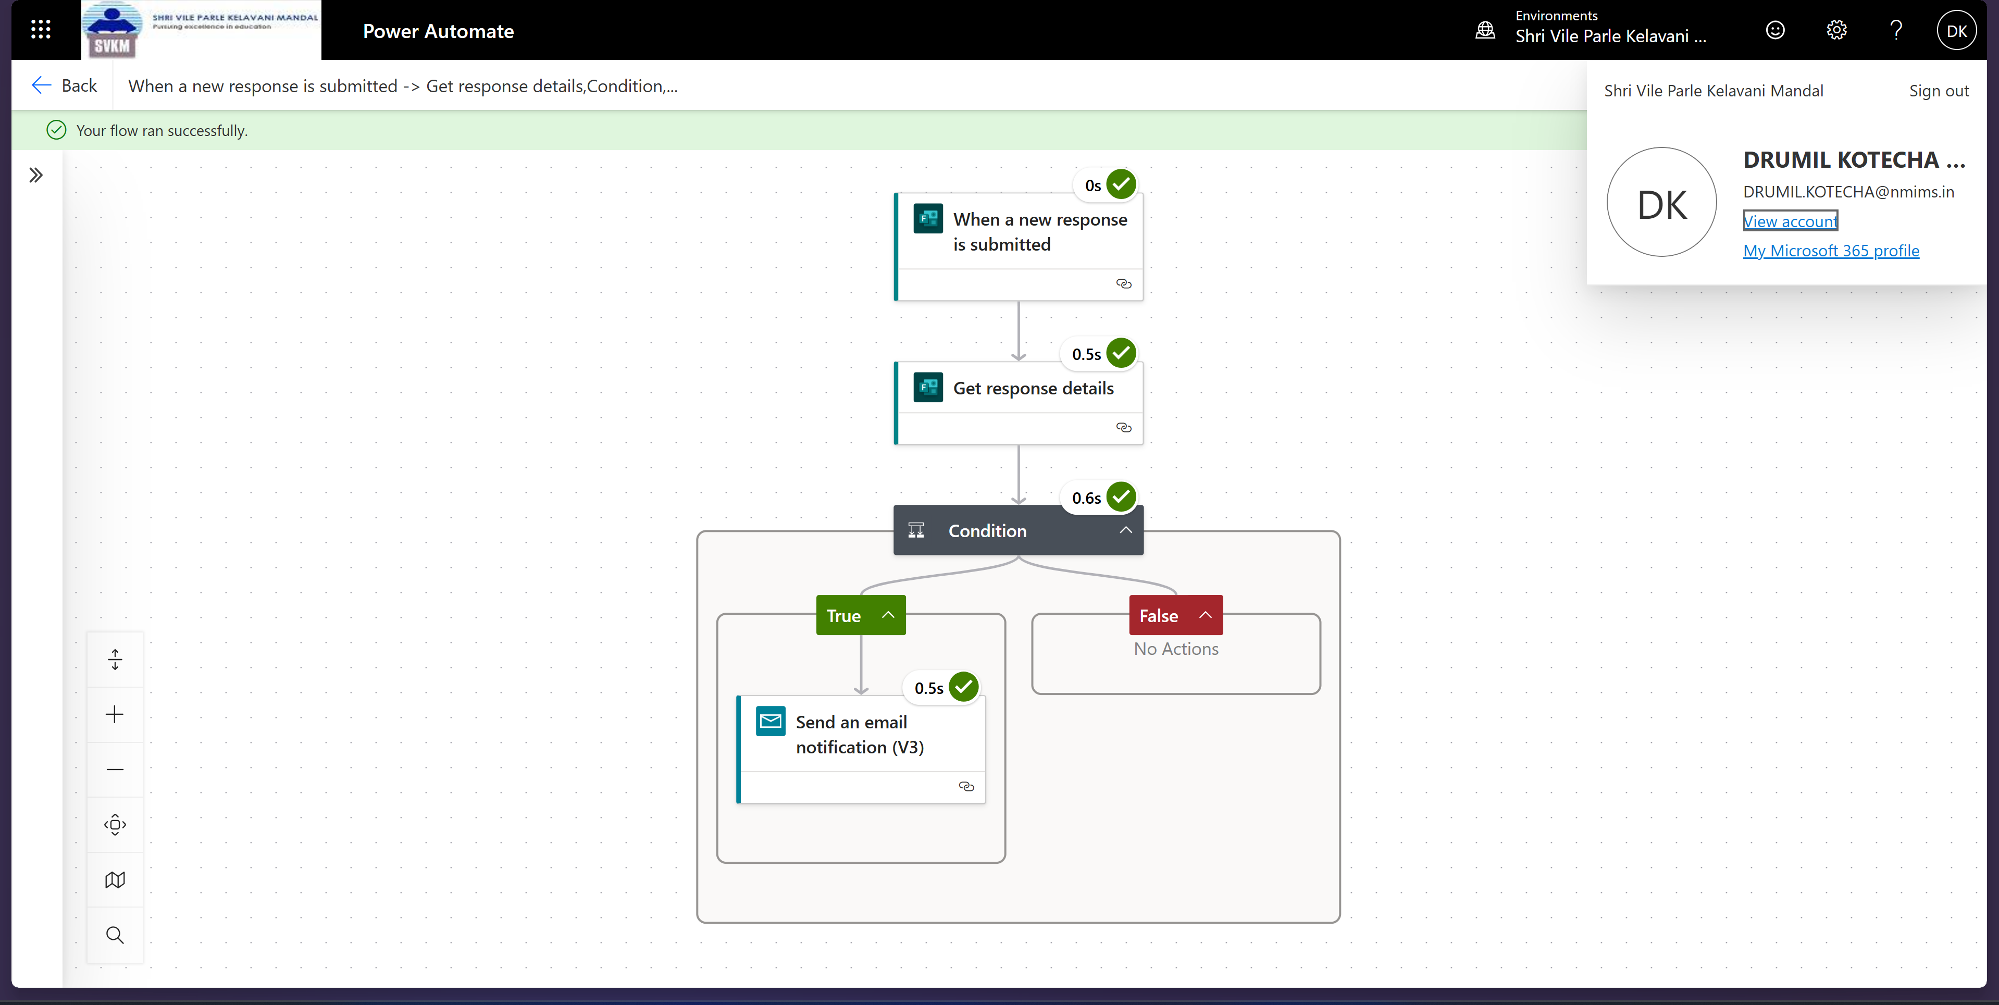

Output:

